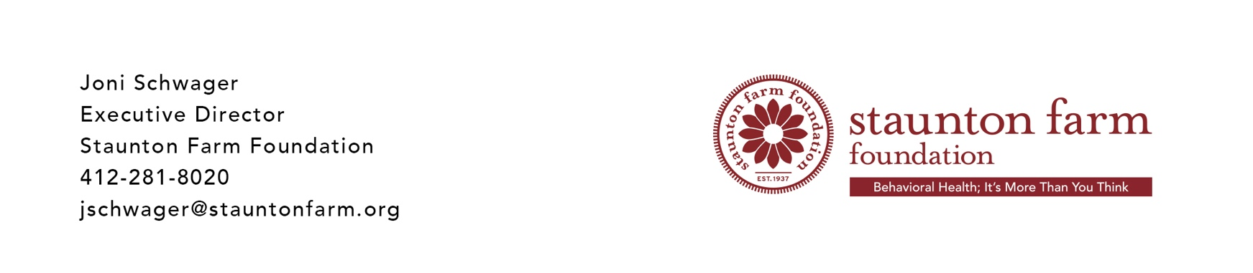

**FOR IMMEDIATE RELEASE**

PITTSBURGH, Pa. April 9, 2020: The Staunton Farm Foundation has awarded behavioral health grants of close to $450,000 in response to the COVID19 pandemic.

“I am proud of Staunton Farm Foundation’s quick response to the region’s behavioral health organizations and their constituents. The foundation’s grantees serve the most vulnerable people in our region and both have extremely limited resources, especially those in rural counties outside Allegheny”, said Joni Schwager, Executive Director.

Over the last two weeks, some of the foundation’s grantees include:

Neighborhood Allies: Beams to Bridges Mental Health Training Program $37,600

The Children's Institute: Expansion of Telehealth Capabilities $20,000

The Open Door: Emergency Needs $25,807

Westmoreland Case Management and Support: Client Services $27,500

Women's Center of Beaver County: Off-site Shelter $10,260

Center for Life: Emergency Medical Fund ` $25,000

Washington City Mission: General Operating $25,000

Glade Run Foundation: Telehealth $25,000

Center for Community Resources: Emergency Needs $25,000

Every Child, Inc: Telehealth $20,000

It is well past time we pay attention to people’s mental health. Depression is one of the most common chronic conditions and is commonly a co-traveler with each and every health condition, yet it is a condition that is not taken seriously by society, payers and employers across the nation. Today, we are seeing a huge increase in crisis calls because people are isolated, anxious and need help. Consequently, we are ill prepared to meet the needs we are confronted with today.

The foundation is still accepting requests. For more information, see our website at [www.stauntonfarm.org](http://www.stauntonfarm.org)

# *About the Staunton Farm Foundation*

# The Staunton Farm Foundation is dedicated to improving the lives of people who live with mental illness and substance use disorders. The Foundation works to enhance behavioral health treatment, support, and recovery through grant making to nonprofit organizations in ten southwestern Pennsylvania counties. (Allegheny, Armstrong, Beaver, Butler, Fayette, Greene, Indiana, Lawrence, Washington, and Westmoreland).

(###)

**Staunton Farm Foundation gives $450,000 for Emergency Behavioral Health Needs**